**Pressure Paper Material**

Related Papers:

<https://ieeexplore.ieee.org/abstract/document/8256792>

<https://www.mdpi.com/1424-8220/20/15/4247>

Pressure-flowrate relationship and leakage detection formulas:

<https://www.researchgate.net/profile/Donghoon-Shin-5/publication/225401927_Numerical_study_on_leakage_detection_and_location_in_a_simple_gas_pipeline_branch_using_an_array_of_pressure_sensors/links/0c960527ac145d0c1d000000/Numerical-study-on-leakage-detection-and-location-in-a-simple-gas-pipeline-branch-using-an-array-of-pressure-sensors.pdf>

Danfoss Datasheet



Calculations:

* Accuracy (from datasheet) = ± 0.5% FS (typically)
* Expected Pressure-Current mapping : 0-16 Bar => 4-20 mA
* Resistance used to obtain voltage = 150 Ω
* Expected Pressure-Voltage mapping : 0-16 Bar => 0.6-3 V
* Accuracy in voltage observed = ± 0.5% * 2.4V = ± 0.012 V
* Expected Voltage range = 0.6±0.012 - 3±0.012V
* Mapping of pressure voltage to pressure:

Pressure = ((((Pressure Voltage)/150)*1000) – 4) Bar

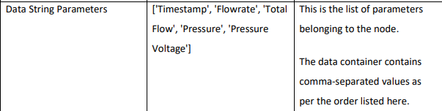

Refer to given water quality monitoring documentation pdf for more details:



*2.1. Data Collection Level*

Each node is composed of a pressure transducer that converts the hydraulic pressure into an electrical signal. Its measuring range should cover the range of possible pressures at the sensor location to ensure a reliable reading of the variable and to avoid damage to the rest of the electronics. Any change in the operational conditions of the system affects the pressure in the pipes according to the energy conservation equation between two points of the network (Equation (1)).

Where *P* is the pressure; *v* is the flow velocity; *z* is the elevation; *γ* is the specific water weight; *HA* is the energy added by a pumping station; *HL* is friction losses in pipes; and *HE* is the energy extracted by turbines. This demonstrates that leaks or breakdowns in the water supply network (modify v in Equation (1)) will give pressure readings out of their normal range at downstream points. This monitoring system will detect and locate leaks in real-time, thus improving the system’s hydraulic performance. The pressure measurement is also used to understand the behaviour of the hydraulic system in different operation scenarios to improve the management of adverse situations.

Detection of anomalous pump operation:

The pumping station studied is located on a secondary pipe that supplies water to a municipal tank. The start/stop of the pump depends on the level of the tank. The pressure sensor was installed in the pipe connecting the pump to the tank. Analysis of the pressure variations allows the detection of a malfunction of the pump and the correction of possible system failures.  Figure 14 shows that false start events were detected and repeated at specific periods. This can cause long-term pump deterioration, as well as unnecessary energy consumption. By studying the pressure record, the cause of the false starts was identified: an erroneous signal from the tank level sensor that sent a start command to the pump control system.

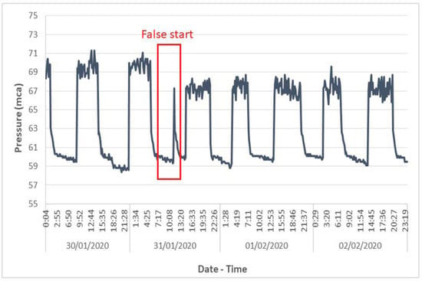

**Figure 14.** Pump false start.